1. **CREATE CUSTOMERS TABLE**

CREATE TABLE customers (

id NUMBER PRIMARY KEY,

customer_id VARCHAR2(20),

customer_name VARCHAR2(50),

customer_acc_no VARCHAR2(20),

password VARCHAR2(50),

Date_of_birth DATE,

gender VARCHAR2(10),

State VARCHAR2(50),

City VARCHAR2(50),

Zipcode VARCHAR2(10),

Street_no VARCHAR2(20),

House_no VARCHAR2(20),

status VARCHAR2(20),

created_at TIMESTAMP DEFAULT SYSDATE,

updated_at TIMESTAMP DEFAULT SYSDATE

);

1. **CREATE CUSTOMER_CONTACT_INFO TABLE**

CREATE TABLE customer_contact_info (

id NUMBER PRIMARY KEY,

contact_no VARCHAR2(20),

status VARCHAR2(20),

created_at TIMESTAMP DEFAULT SYSDATE,

updated_at TIMESTAMP DEFAULT SYSDATE

);

1. **ADD CUSTOMER_ID AS A FOREIGN KEY AT CUSTOMER_CONTACT_INFO TABLE FROM CUSTOMERS TABLE**

ALTER TABLE customer_contact_info ADD CONSTRAINT fk_customer_id

FOREIGN KEY (customer_id)

REFERENCES customers(id);

1. **CREATE OWNERS TABLE.**

CREATE TABLE owners (

owner_id NUMBER PRIMARY KEY,

name VARCHAR2(50),

password VARCHAR2(50),

Date_of_birth DATE,

State VARCHAR2(50),

City VARCHAR2(50),

Street_no VARCHAR2(20),

House_no VARCHAR2(20),

Zip_code VARCHAR2(10),

status VARCHAR2(20),

created_at TIMESTAMP DEFAULT SYSDATE,

updated_at TIMESTAMP DEFAULT SYSDATE

);

1. **CREATE OWNER_CONTACT_INFO TABLE.**

CREATE TABLE owner_contact_info (

id NUMBER PRIMARY KEY,

owner_id NUMBER,

contact_no VARCHAR2(20),

status VARCHAR2(20),

created_at TIMESTAMP DEFAULT SYSDATE,

updated_at TIMESTAMP DEFAULT SYSDATE

);

1. **ADD OWNER_ID AS A FOREIGN KEY AT OWNER_CONTACT_INFO TABLE FROM OWNERS TABLE**

ALTER TABLE owner_contact_info ADD CONSTRAINT fk_owner_id

FOREIGN KEY (owner_id)

REFERENCES owners(owner_id);

1. **CREATE OFFICE_SPACE TABLE.**

CREATE TABLE office_space (

office_id NUMBER PRIMARY KEY,

owners_id NUMBER,

floor_no NUMBER,

total_cost NUMBER,

space_name VARCHAR2(50),

recreational_corner VARCHAR2(10),

size_of_room VARCHAR(20),

parking_space VARCHAR2(10),

area_in_sqrmtr NUMBER,

cost_of_each_room NUMBER,

type_of_rooms VARCHAR2(20),

shared_space VARCHAR2(20),

shared_gender VARCHAR2(10),

numbers_of_shares NUMBER,

state VARCHAR2(50),

city VARCHAR2(50),

street_no VARCHAR2(20),

house_no VARCHAR2(20),

zipcode VARCHAR2(10),

monthly_availability DATE,

status VARCHAR2(20),

created_at TIMESTAMP DEFAULT SYSDATE,

updated_at TIMESTAMP DEFAULT SYSDATE,

FOREIGN KEY (owners_id) REFERENCES owners(owner_id)

);

1. **CREATE LIVING_SPACE TABLE.**

CREATE TABLE living_space (

House_no NUMBER PRIMARY KEY,

owner_id NUMBER,

space_name VARCHAR2(50),

Full_Furnished_room VARCHAR2(20),

Total_floor NUMBER,

Area_in_sqrmtr NUMBER,

cost NUMBER,

number_of_rooms NUMBER,

shared_space VARCHAR2(20),

shared_gender VARCHAR2(10),

numbers_of_shares NUMBER,

state VARCHAR2(50),

city VARCHAR2(50),

zipcode VARCHAR2(10),

street_no VARCHAR2(20),

monthly_availability DATE,

status VARCHAR2(20),

created_at TIMESTAMP DEFAULT SYSDATE,

updated_at TIMESTAMP DEFAULT SYSDATE,

FOREIGN KEY (owner_id) REFERENCES owners(owner_id)

);

1. **CREATE OFFICE_SPACE_IMAGES TABLE.**

CREATE TABLE office_space_images (

id NUMBER PRIMARY KEY,

officeid NUMBER,

images VARCHAR2(100),

status VARCHAR2(20),

created_at TIMESTAMP DEFAULT SYSDATE,

updated_at TIMESTAMP DEFAULT SYSDATE,

FOREIGN KEY (officeid) REFERENCES office_space(office_id)

);

1. **CREATE PAYMENT_INFO TABLE.**

CREATE TABLE payment_info (

payment_id NUMBER PRIMARY KEY,

customer_acc_no VARCHAR2(20),

customer_id NUMBER,

Amount NUMBER,

payment_date DATE,

payment_mode VARCHAR2(20),

status VARCHAR2(20),

created_at TIMESTAMP DEFAULT SYSDATE,

updated_at TIMESTAMP DEFAULT SYSDATE,

FOREIGN KEY (customer_id) REFERENCES customers(id)

);

1. **CREATE OFFICE_BOOKING TABLE.**

CREATE TABLE office_booking (

booking_id NUMBER PRIMARY KEY,

space_id NUMBER,

booking_type VARCHAR2(20),

customers_id NUMBER,

start_date DATE,

end_date DATE,

status VARCHAR2(20),

created_at TIMESTAMP DEFAULT SYSDATE,

updated_at TIMESTAMP DEFAULT SYSDATE,

FOREIGN KEY (space_id) REFERENCES office_space(office_id),

FOREIGN KEY (customers_id) REFERENCES customers(id)

);

1. **CREATE LIVING_BOOKING TABLE.**

CREATE TABLE living_booking (

booking_id NUMBER PRIMARY KEY,

spaceid NUMBER,

booking_type VARCHAR2(20),

customers NUMBER,

start_date DATE,

end_date DATE,

status VARCHAR2(20),

created_at TIMESTAMP DEFAULT SYSDATE,

updated_at TIMESTAMP DEFAULT SYSDATE,

FOREIGN KEY (spaceid) REFERENCES living_space (House_no),

FOREIGN KEY (customers) REFERENCES customers(id)

);

1. **INSERT INTO CUSTOMERS**

INSERT INTO customers (id,customer_name, customer_acc_no, password, Date_of_birth, gender, State, City, Zipcode, Street_no, House_no, status) VALUES

(10,'Grace Zhang', '0123456789', 'passwordqrs', TO_DATE('1980-12-05', 'YYYY-MM-DD'), 'Female', 'Washington', 'Seattle', '98101', '890 Pike St', 'Unit 201', 'Inactive');

1. **SEE FROM CUSTOMERS TABLE**

SELECT * FROM customers

1. **SEE ALL FROM CUSTOMER_CONTACT_INFO TABLE**

SELECT * FROM customer_contact_info;

1. **PRINT ALL OWNERS WITH TABLE EXAMPLE**

select * from owners;

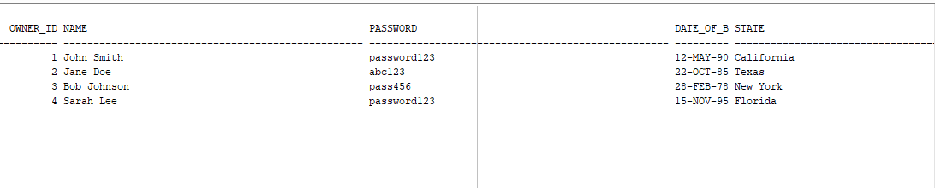

1. **SEE ALL OWNERS CONTACT INFORMATION**

SELECT * FROM owner_contact_info;

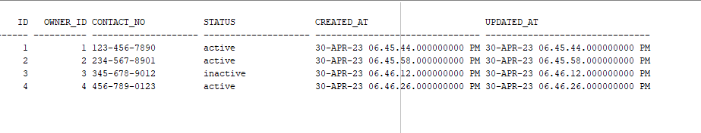

1. **ADD DATA INTO OFFICE SPACE.**

INSERT INTO office_space

(office_id, owners_id, floor_no, total_cost, space_name, recreational_corner, size_of_room, parking_space, area_in_sqrmtr, cost_of_each_room, type_of_rooms, shared_space, shared_gender, numbers_of_shares, state, city, street_no, house_no, zipcode, monthly_availability, status, created_at, updated_at)

VALUES

(4,2,5,10000, 'Office 1', 'Yes', 'Large', 'Yes', 200, 5000, 'Private', 'No', 'Yes', 5, 'Delhi', 'delhi', '123 Main Street', 'Ghm 100', '144101', TO_DATE('2023-12-05', 'YYYY-MM-DD'),'Active' , SYSDATE, SYSDATE);

1. **SEE INFO ALL FROM OFFICE SPACE**

SELECT * FROM office_space;

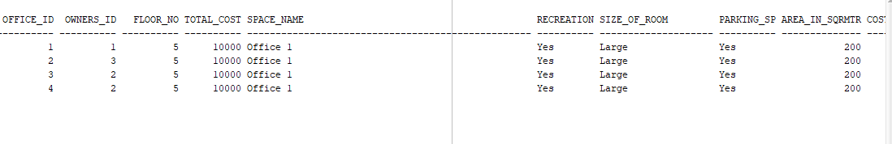

1. **INSERT DATA INTO OFFICE_SPACE_IMAGES**

INSERT INTO office_space_images (id, officeid, images, status, created_at, updated_at)

VALUES

(10, 2, 'https://example.com/image10.jpg', 'active', SYSDATE, SYSDATE);

1. **FETCH ALL IMAGES FROM OFFICE_SPACE_IMAGE.**

SELECT * FROM office_space_image;

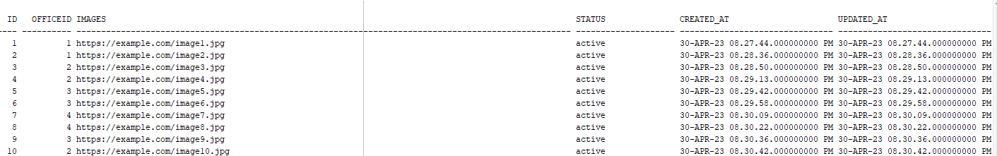

1. **COMBINE OFFICE SPACE TABLE WITH IMAGES FROM OFFICE SPACE IMAGES TABLE**

SELECT o.floor_no, o.total_cost, o.space_name, i.images

FROM office_space o

JOIN office_space_images i

ON o.office_id = i.officeid;

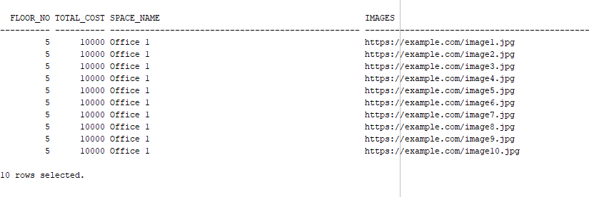

1. **INSERT DATA INTO LIVING SPACE TABLE.**

INSERT INTO living_space (House_no, owner_id, space_name, Full_Furnished_room, Total_floor, Area_in_sqrmtr, cost, number_of_rooms, shared_space, shared_gender, numbers_of_shares, state, city, zipcode, street_no, monthly_availability, status, created_at, updated_at)

VALUES

('123', 1, 'Apartment 1', 'Yes', 5, 100, 50000, 2, 'Yes', 'Female', 2, 'Haryana', 'Ambala', '10001', '123 Main St', TO_DATE('2023-12-05', 'YYYY-MM-DD'), 'Active', SYSDATE, SYSDATE);

1. **SELECT ALL ROWS FROM LIVING SPACE TABLE**

SELECT * FROM living_space;

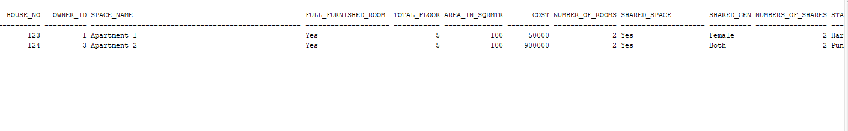

1. **INSERT INTO PAYMENT_INFO**

INSERT INTO payment_info (payment_id, customer_acc_no, customer_id, Amount, payment_date, payment_mode, status, created_at, updated_at)

VALUES

(1, '1234567890', 1, 10000, TO_DATE('2023-01-05', 'YYYY-MM-DD'), ', 'Credit Card', 'Paid', SYSDATE, SYSDATE),

1. **SELECT FROM PAYMENT_INFO**

SELECT * FROM payment_info

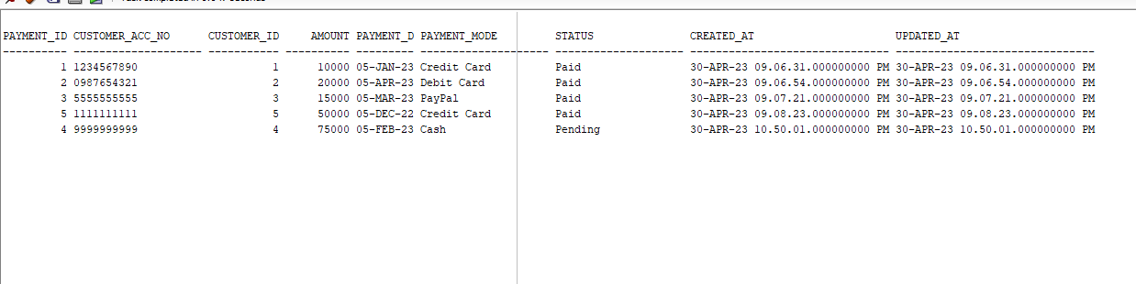

1. **INSERT DATA INTO OFFICE_BOOKING**

INSERT INTO office_booking (booking_id, space_id, booking_type, customers_id, start_date, end_date, status, created_at, updated_at)

VALUES (1, 1, 'office', 1, TO_DATE('2023-02-10', 'YYYY-MM-DD'), TO_DATE('2024-01-01', 'YYYY-MM-DD'), 'cancelled', SYSDATE, SYSDATE);

1. **FETCH DATA FROM OFFICE_BOOKING**

SELECT * office_booking;

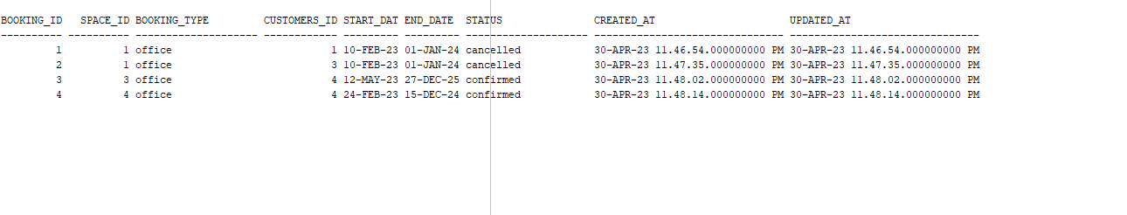

1. **INSERT DATA INTO LIVING_BOOKING**

INSERT INTO living_booking (booking_id, spaceid, booking_type, customers, start_date, end_date, status, created_at, updated_at)

VALUES (1, 123, 'living', 5, TO_DATE('2023-01-05', 'YYYY-MM-DD'), TO_DATE('2023-12-05', 'YYYY-MM-DD'), 'confirmed',SYSDATE, SYSDATE);

1. **FETCH DATA FROM LIVING_BOOKING**

SELECT * living_booking;

